Terms of Reference
Expression of Interest for Hydroelectric Power Plants (HPPs) in Ethiopia
- Screening and Diagnostic Study -

Background
Ethiopia is one of the fastest growing countries in Sub-Saharan Africa and has seen rapid growth in its electricity demand and generation capacity. The total installed capacity has more than quadrupled between 2009 and 2022 and will reach about 13,000 MW by 2028, with the great majority of this capacity being hydropower.
The installed capacity of the existing major hydroelectric power plants (HPPs) operated by Ethiopia Electric Power company (EEP) is as follows:
HPP | Capacity (MW) | Year of Construction (E.C.)
Koka (Awash 1) | 43.2 | 1960
Tis Abay 1 | 12 | 1953
Awash 2 | 34 | 1966
Fincha | 134 | 1974
Awash 3 | 34 | 1968
Melka Wakena | 153 | 1988
Tis Abay 2 | 73.6 | 2001
Gilgel Gibe 1 | 184 | 2004
Gilgel Gibe 2 | 420 | 2010
Beles | 460 | 2010
Tekeze | 300 | 2010
Fincha Amerti Neshe | 97 | 2012
Gilgel Gibe 3 | 1870 | 2017
Abba Samuel | 6.6 | 2017
Genale-Dawa III | 254 | 2020
GERD 1 (phase 1) | 750 | 2023

The aggregate installed capacity of these projects is 4825 MW. The Grand Ethiopia Renaissance Dam (GERD) when complete will have 5150 MW of capacity and Koyesha HPP, with 1800 MW capacity is under construction.
Five of the existing hydroelectric projects are over 40 years old, the age at which complete refurbishment of the electrical and mechanical plant is typically undertaken.
A further three plants are between 20 years and 40 years old, at which age it is common to start replacing or refurbishing control and protection systems and ancillary equipment, and reportedly some of the more recent plants could benefit from major maintenance, replacement of parts and provision of spares.
EEP and the World Bank is seeking the services of a consulting firm (“the Consultant”) to undertake a scoping study to identify the refurbishment requirements of the older HPPs in Ethiopia and develop a priority list for future detailed assessments of the refurbishment needs.

Objective of the Assignment
The objective of this assignment is to diagnose the operation of the existing HPPs and select projects for further study for detailed assessment of refurbishment needs. The World Bank may support the detailed assessment of these shortlisted HPPs in the future.

Scope of work
An initial pre-screening has been carried out by EEP and the World Bank in which twelve HPPs have been identified as potentially requiring some refurbishment. These plants are as follows:
ID | HPP | Capacity (MW) | Year of Construction (E.C.)
1 | Koka (Awash 1) | 43.2 | 1960
2 | Tis Abay 1 | 12 | 1953
3 | Awash 2 | 34 | 1966
4 | Finchaa | 134 | 1974
5 | Awash 3 | 34 | 1968
6 | Melka Wakena | 153 | 1988
7 | Tis Abay 2 | 73.6 | 2001
8 | Gilgel Gibe 1 | 184 | 2004
9 | Gilgel Gibe 2 | 420 | 2010
10 | Beles | 460 | 2010
11 | Tekeze | 300 | 2010
12 | Fincha Amerti Neshe (FAN) | 97 | 2012

The location of these plants is shown on the map below:
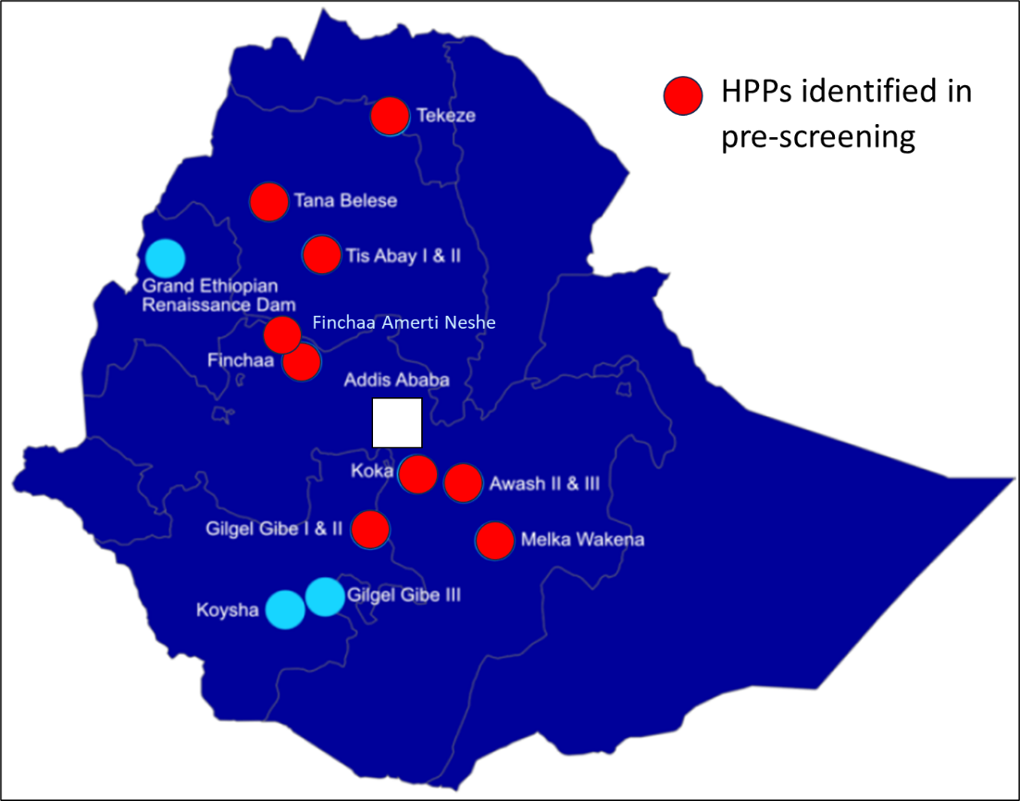

A three-stage approach to the study is envisaged:
- Screening study of around 10 to 12 projects
- Workshop to agree the relative merits of each project
- Priority list recommending 3 to 4 selected projects for further detailed assessment.
The scope of the consulting services will include the following detailed tasks:

Task 1: Screening Study
The first stage of the study is to screen the identified HPPs in order to shortlist between two and four plants for further study. The shortlisting will consider the prioritisation of the plants by EPP, the economic benefit of refurbishment, and will also include consideration of the budget available for the future studies and refurbishment works and other criteria to be agreed.
The following activities are envisaged in Task 1:

Data Gathering
Basic data relating to the plants should be obtained to provide a basis for the screening. This data may include:
- National topographic mapping;
- Hydrological data
- Layout of plant
- Plant characteristics
- Plant performance data (energy production, availability etc)
- Condition data including age of plant and any refurbishment / replacement work undertaken
- Environmental and social data
- Interconnection / transmission data
While some of this data may be available from EEP on request, it is likely that a visit to Addis Ababa will be required to assess the availability of data and define the data requirements.

Screening studies
Based on the data received, a screening study will be undertaken to define among other criteria:
- Age and condition of plant
- Known problems and repair requirements
- High level estimation of work requirements to refurbish and extend the life of the plant and associated costs
- Role of the plant in the power system
- Opportunities for upgrading or re-purposing (including peaking operation and improved flexibility)
- Implication of muti-purpose use of water on Power generation
- Hydrological considerations, such as sustainability of flows, adequacy of spillway
- Environmental and social issues, including regional equity as well as security considerations.
- Ability to evacuate additional electricity and any upgrades to grid network required.
- High level cost-benefit analysis, considering efficiency improvements, increased availability, reduced maintenance costs and any flexibility improvements as benefits.

Reporting
A report shall be prepared to cover the work undertaken in Task 1, and to present the results of the assessments for each of the HPPs studied. The results should be presented in a format enabling comparison of results for all sites, preferably in the form of a multi-criteria analysis.

Task 2: Workshop and Task 3 Scoping
Following submission of the Task 1 Screening Report a workshop will be held in Addis Ababa. The objective of this workshop will be for the Consultant to disseminate the results of the study, and for the stakeholders including EEP, World Bank and MoWE, to discuss and agree the selection of HPPs to take forward for further study.
In preparation for this workshop the Consultant shall prepare a presentation of the assessment carried out for each of the screened HPPs, and a comparison between the projects.
Following the workshop the Client will advise on the HPPs to be taken forward to Task 3.
The Consultant will then prepare and submit a Scoping Report, detailing the work to be undertaken in Task 3, together with any proposed adjustment to the schedule and cost of services. Following agreement of the scope, schedule and the cost of services, the Client will issue a notice to proceed with the Task 3 studies.

Task 3: Diagnostic study and priority list for detailed assessment
The objective of the Task 3 studies is to define the scope of refurbishment and upgrading that is economically viable for each of the selected HPPs. The diagnostic study should be defined in sufficient detail to enable the projects to proceed to detailed feasibility assessment. It is envisaged that the implementation will be undertaken through procurement of one or more contractors, or through a PPP partner that would take on responsibility for implementation.
Following the diagnostic study, a priority list of 3-4 HPPs should be recommended for future detailed feasibility studies into their refurbishment. For the purpose of scheduling and budgeting, and that comprehensive refurbishment will be required, including both civil, electro-mechanical and hydromechanical works. The HPPs are considered to include the associated transformers, switchyards/substations, but not the transmission lines. However, if the grid connection imposes constraints on the evacuation of power from the HPPs, this shall be noted, and additional studies may be commissioned.
An overview of the typical tasks to be undertaken in under Task 3 is presented below, although the detailed scope will be agreed once the HPPs are selected.

Data Gathering
Further data shall be gathered relating to the HPPs, including data relating to the physical environment, project design, operation and maintenance and other data deemed by the Consultant to be relevant for the studies.
Data gathered during the study shall be stored in electronic format and shall be accessible by the Client following completion of the services.

Site Visit
The Consultant shall visit the HPPs to assist with determining the condition of the plant. The Consultant’s team shall include staff with appropriate discipline experience, based on the preliminary assessment carried out in Task 1.
At the time of the site visits, a security assessment will be carried involving the relevant stakeholders, including EEP and other stakeholders from the Government of Ethiopia. Relevant security precautions will be taken based on the outcome of this security assessment.
A typical checklist for the site visit is provided in Appendix A, although the Consultant may use its own version.
A site visit report shall be submitted within two weeks of completion of the site visit, detailing the key findings from the site visit.

Diagnostic Study and Refurbishment Requirement
Based on the data acquired and the site visit, the Consultant shall determine the refurbishment requirement and upgrade opportunities for each project. Where inspections and tests have not been possible, the Consultant shall base the requirements on the typical refurbishment required for hydroelectric plant of a similar age and condition.
The refurbishment requirements shall be detailed sufficiently to estimate the cost of refurbishment and benefits that will accrue.

Sustainability, Safety, Environmental and Social Issues
The Consultant shall carry out an appraisal of the sustainability of each HPP including assessment of the hydrology in relation to water availability for generation, changes to upstream abstraction and downstream water requirements for irrigation. An assessment of the adequacy of the spillway to discharge flood flows will also be carried out.
An appraisal shall be carried out of environmental and social issues relating to the HPPs, including issues that might affect World Bank’s ability to finance refurbishment.

Implementation Schedule and Cost estimate
An implementation schedule for the refurbishment works shall be prepared, taking into account the need to minimise down-time and energy loss, and system requirements for ancillary services.
A detailed level cost estimate shall be prepared for the refurbishment works, including the cost of consultancy for any specialist testing required to determine the plant condition.

Cost-Benefit Analysis
Cost-benefit analysis shall be carried out to assess the economic viability of the proposed refurbishment works. The costs shall include any loss of revenue from lost generation. Benefits shall include increased energy due to efficiency gains, increased availability and reduced maintenance costs. Carbon shadow pricing in line with World Bank’s standard methodology shall be applied.

Recommendations for implementation
Taking into consideration the nature of the refurbishment works, recommendations shall be given for the approach to implementation, including options for traditional government funded and PPP models. For activities where the condition of equipment may only be determined following dismantling of the plant, proposal shall be given for the sequencing and contractual arrangements for undertaking this work.
Based on the above, a list of priority projects of 3-4 projects should be developed to inform future detailed assessments of the refurbishment needs. The priority projects should be chosen based on a well-developed multi-criteria assessment of the results from sections 3.3.1-3.3.6 of this Terms of Reference and in conjunction with the Client.

Reporting
A report shall be prepared at the end of Task 3 which details the studies undertaken, the conclusions reached and the recommendations for implementation. The report shall include test results, performance indicators and calculations that support the analysis and conclusions. The Site Visit Report shall be appended to this report.
The methodology and assessment of the projects used to develop the priority list should be included in this report.

Deliverables and time schedule
The Consultant shall prepare and submit the following reports on the studies:
- Task 1 Screening Study Report
- Task 2 Workshop Presentation
- Scoping Report and Workplan for Task 3
- Task 3 Site Visit Report
- Task 3 Diagnostic Study and Priority Interventions Report
Deliverables shall be provided in agreed electronic formats.
The implementation schedule of this assignment is as follows:

Activities | Estimated time for completion
Task 1 Screening Study Report | 8 weeks after award
Task 2 Workshop | 10 weeks after award
Scoping Report and Workplan for Task 3 | 2 weeks after Task 2 Workshop
Task 3 Site Visit Report | 5 weeks after Task 3 Instruction to Proceed
Task 3 Diagnostic Study and Priority Interventions Report (draft) | 10 weeks after Task 3 Instruction to Proceed
Task 3 Diagnostic Study and Priority Interventions Report (final) | 2 weeks after receipt of Client’s comments

Consultant’s team and qualifications
The Consultant will be an international company with extensive experience in the study and design of refurbishment works for hydroelectric power projects, including study or design of refurbishment of 15 hydroelectric projects larger than 30 MW in the past 20 years. The company shall have experience of working in East Africa, and experience in Ethiopia will be considered an advantage.
It is expected that the Consultant will associate with an Ethiopian company with appropriate experience, that will provide technical and logistical support, including support with data gathering.
The Consultant shall propose a team to undertake the study that provides adequate capability in the disciplines of civil engineering, hydromechanical engineering, mechanical engineering and electrical engineering. It is expected that the core team will undertake the site inspections, and may be supplemented and supported by additional home-office staff. It is expected that the core team undertaking the study will comprise:
Position | Role
Civil Engineer / Dam Expert | Assess condition of all civil and structural engineering components the hydroelectric plants.
Mechanical Engineer | Assess condition of all mechanical and hydro-mechanical components of the hydroelectric plants.
Electrical Engineer | Assess condition of all electrical, electronic and transmission components of the hydroelectric plants, including SCADA and communications.
The Consultant shall nominate a team leader who shall have the responsibility for leading the project team, and have overall responsibility for the project deliverables.
CVs shall be presented for all staff performing discipline leadership roles, as well as any staff providing specialist support.

Client’s Inputs and Counterpart Staff

Services and Facilities
- Reports, data, documentation and drawings of the facilities
- Access to Hydroelectric Plants
- Support in procurement of data from government and other agencies
- Local information on local transportation, accommodation and security update

Professional and Support Personnel
- Personnel to guide and facilitate the site visit, including security personnel should the security assessment deem necessary
- Other as agreed

Submission of Proposals
The Consultant’s offer shall be submitted in two sections:
- Technical Proposal: (i) Consultant’s organization; (ii) Consultant’s experience related to off-grid solar sector and the objectives of this assignment; (iii) Comment/suggestion on the TOR; (iv) Description of approach, methodology and work plan, including time and resourcing for in-country work and stakeholder engagement; (v) Table showing level of effort for each task ; and (vi) Team composition, summary of the skills, experience, nationality, and gender of each core team member, task assignments and level of effort; The following should be included as annex material: (i) Detailed CVs of key personnel; (ii) Detailed work schedule.
- Financial Proposal: (i) Financial proposal submission form (to be completed and signed); (ii) Summary of costs, broken down by major component (iii) Breakdown of daily fees; (iv) Summary of any optional items for consideration by the WB team.

The Financial Proposal shall include provision for time spent in meetings and organizing consultation events, as needed. The cost of obtaining any required data, reports or other documents/materials must be included in the Consultant’s core offer. The Financial Proposal must list the unit costs of travel and per diem assumed by the Consultant in preparing their offer.
The financial proposal should provide a breakdown of daily rates and any additional third-party costs. All taxes and charges should be included. The Consultant’s travel, accommodation, telecommunications and any other reasonable expenses that are incurred in the acceptable execution of this work should be included in the amount proposed in the financial proposal.

Appendix A: Typical check-list for visiting the Hydroelectric Power Plants.
- Health and Safety
  - Safety briefing?
  - Provision of personal protection equipment (PPE)?
  - Apparent culture of safety?
  - Trip hazards?
  - Handrails / protection against falls?
  - Life vests / buoys?
  - Cages to rotating parts and electrical equipment?
  - Control cabinets locked?
  - Safety processes and system such as permits to work, padlock systems, signature sheets, safety records, test and calibration sheets etc?
  - Safety manager?

- General appearance and organisation
  - Tidy site?
  - Weatherproof buildings?
  - Leaks (oil or water)?
  - Vegetation under control?
  - Rust / paintwork condition?
  - Spares inventory and old equipment storage?

- Operation
  - Staff structure (station, central support and head office) – organisation chart if possible or staff numbers by grade? Does this seem over/understaffed?
  - Local or remote operation (assume hydros each have a control room where the operator physically controls the output in accordance with instructions from the national system operator)?
  - Dispatch procedures – who instructs dispatch? How is it communicated (telephone / radio / digital)?

- Maintenance
  - Existence of formal inspection / maintenance plan?
  - Inspection / maintenance records? Paper or computerised?
  - Records of energy production and availability?
  - How much maintenance in-house how much external contractors?
  - Is staff structure / capability appropriate?

- Problems / Issues to be addressed
  - Availability (high forced outage rate?
  - Grid issues (does grid failure impact production)?
  - High maintenance requirement (does equipment break-down frequently requiring repair or replacement?
  - Is equipment obsolete (difficulty getting spares and replacements)?
  - Condition of structural elements (cracks, spalling, erosion, undercutting etc)
  - Leakage of pipework, joints etc
  - Leakage of gate and valve seals?
  - Difficulties with synchronisation?
  - Sediment encroachment on intake or other sediment management issues?
  - Floating vegetation potentially blocking screens or entering waterways?

- Opportunities
  - Ability to increase capacity and flexibility or change way plant is operated to increase the value of the plant to the power system?
  - Opportunity to operate all plants from central operating room to reduce operating costs?
  - Ability to operate plant more efficiently (eg less spillage) if better inflow information available.

Gender balance will be reflected in the technical score.

